|  |  |
| --- | --- |
| Description: 18897 CIC A4 Portrait WordTemp_cropped.jpg | **ASSIGNMENT COVER SHEET** |
|  | |
|  | |
| |  |  | | --- | --- | | **SUBJECT NUMBER & NAME** | 36103 Statistical Thinking for Data Science | | **STUDENT NAMES & IDs**  **(SURNAME, FIRST NAME, STUDENT ID)** | Arunachalam, Abishek (SID: 13001262)  Jiang, Benjamin (SID: 12875314)  Pelayre, Anne Gorge (SID: 13102191)  Raghavan, Saminathan (SID:13075597)  Ramal, Miguel (SID: 00060259) | | **TEAM NAME** | SKEPTICS | | **STUDENT EMAIL** | [abishek.arunachalam@student.uts.edu.au](mailto:abishek.arunachalam@student.uts.edu.au), [benjamin.jiang@student.uts.edu.au](mailto:benjamin.jiang@student.uts.edu.au), [annegorge.pelayre@student.uts.edu.au](mailto:annegorge.pelayre@student.uts.edu.au), [saminathan.raghavan@student.uts.edu.au](mailto:saminathan.raghavan@student.uts.edu.au), [miguel.ramal@student.uts.edu.au](mailto:miguel.ramal@student.uts.edu.au) | | **DUE DATE** | 30 April 2018 | | **ASSESSMENT ITEM NUMBER/TITLE** | AT2 Data analysis project, Part A: Project Plan | | * I/We confirm that the work submitted conforms with the university’s guidelines on academic integrity.   *Refer to the UTS policy on ‘Advice to Students on Good Academic Practice’*: <http://www.gsu.uts.edu.au/policies/academicpractice.html>   * I/We am aware of the penalties for plagiarism. This assignment is my/our own work and I/we have not handed in this assignment (either part or completely) for assessment in another subject. * If this assignment is submitted after the due date I/we understand that it will incur a penalty for lateness unless I have previously had an extension of time approved and have attached the written confirmation of this extension.   Please provide details of extensions granted here if applicable \_\_\_\_\_\_\_\_\_\_\_\_\_\_\_\_\_\_\_\_\_\_\_\_\_\_\_\_\_\_\_\_\_\_\_\_\_\_\_\_\_\_\_\_\_\_\_\_\_\_\_  \_\_\_\_\_\_\_\_\_\_\_\_\_\_\_\_\_\_\_\_\_\_\_\_\_\_\_\_\_\_\_\_\_\_\_\_\_\_\_\_\_\_\_\_\_\_\_\_\_\_\_\_\_\_\_\_\_\_\_\_\_\_\_\_\_\_\_\_\_\_\_\_\_\_\_\_\_\_\_\_\_\_\_\_\_\_\_\_\_\_\_\_\_\_\_\_\_\_\_\_  **Signature of Team:** \_\_\_\_\_\_Skeptics\_\_\_\_\_\_\_\_\_\_\_\_\_\_\_\_\_\_\_\_ **­­Date:**  30 / 04 / 2018  If submitted electronically tick here to indicate you agree with the above X | | | |

**Rationale for project**

Gross Domestic Product (GDP) represents the total dollar value of all goods and services a country produced over a specific time period, often referred to as the size of the country’s economy. As one of the most widely used economic indicators, GDP is used to gauge the health of a country’s economy (Investopedia 2018). Given the importance of having a healthy economy to the wellbeing of a country’s citizens, our team considered whether it was possible to predict future GDP of Australia using other historical economic and non-economic information (further discussed in datasets section below).

Our team viewed choosing this topic as a learning opportunity, to better understand how we as individuals and as a community can contribute to the economy. As a team of data analysts without any formal qualifications in economics, will try to decode the economic jargon and provide insights on the important factors that influence a country’s economy.

**Research questions**

As there are two types of GDP that economists use to measure a country’s economy, our regression model will disregard real GDP (economic output adjusted for the effects of inflation) and solely focus on predicting nominal GDP (a country’s economic output without an inflation adjustment). The research questions that we try to answer with the data:

* **Can GDP be accurately predicted given the historical economic and non-economic factors?**
* **Which** **Economic and Non-Economic factors are most influential to nominal GDP?**
* **Does unemployment rate have an effect on GDP?**

**Range of datasets examined and chosen for analysis**

After researching information for economic indicators in Australia, most sources including an e-brief article on the Parliament of Australia website (Woods n.d.) indicate the Australian Bureau of Statistics (ABS) as the main source of economic statistics in Australia.

The ABS site provides a free tool: ABS.Stat that offers web browsing and web services interfaces to display and extract data on multiple themes such as Economy, Health, Industry, Labour, People, Census and other snapshots of Australia.

Whilst measuring GDP can be complicated, the calculation can be done in one of three ways: either by adding up what everyone earned in a year (income approach) or by adding up what everyone spent (expenditure method), or by how much everyone produced (production approach). While each approach should conceptually deliver the same estimate of GDP; if the three measures are compiled independently using different data sources, then different estimates of GDP will result (ABS 2012). To combat this issue, the estimates in the GDP data sets had been pre-balanced by the ABS between the three approaches.

As it did not matter which method we choose as long as we were consistent in our logic, we choose the expenditure method. It had the most readily available information for calculating GDP based on the formula:

**GDP = Consumption + Investment + Government spending + Net Exports.**

In doing so, when choosing our data sets, we were also careful not to choose datasets that were components of each of the methods but rather indicators for the components. For example, we used Consumer Price Index and Business Sales as an indicator of the level of Consumption in the economy.

|  |  |  |
| --- | --- | --- |
| **Expenditure Approach** | **Indicator** | **Link** |
| **GDP** | GDP | <http://stats.oecd.org/restsdmx/sdmx.ashx/GetData/QNA/AUS.B1_GE.CPCARSA.Q/all?startTime=1960-Q1&endTime=2018-Q1> |
| **Consumption** | Consumer Price Index | <http://www.abs.gov.au/ausstats/abs@.nsf/mf/6401.0> |
|  | Sales | [http://stat.data.abs.gov.au/#](http://stat.data.abs.gov.au/) |
| **Investment** | 3-month Monthly Average Interest Rates(%) | <https://www.rba.gov.au/statistics/historical-data.html#interest-rates> |
|  | Expenditure | [http://stat.data.abs.gov.au/#](http://stat.data.abs.gov.au/) |
|  | Labour Force | <http://www.abs.gov.au/AUSSTATS/abs@.nsf/DetailsPage/6202.0Mar%202018?OpenDocument> |
| **Government spending** | Human Development Index(HDI) | [http://hdr.undp.org/en/data#](http://hdr.undp.org/en/data) |
|  | Unemployment | <https://data.oecd.org/unemp/unemployment-rate.htm> |
| **Net Exports** | Balance on Goods and Services | <http://www.abs.gov.au/AUSSTATS/abs@.nsf/DetailsPage/5368.0Feb%202018?OpenDocument> |
|  | Exchange rates | <https://www.rba.gov.au/statistics/historical-data.html#exchange-rates> |

**Data Sources**

* **Gross Domestic Product & Unemployment** – data sourced from The Organisation for Economic Co-operation and Development (OECD).

* **Human Development Index** – data sourced from the United Nations Development Programme (UNDP).
* **Interest Rates & Exchange Rates** – data sourced from the Reserve Bank of Australia (RBA).
* **CPI, Sales, Expenditure, Labour Force & Balance on Goods and Services**- data sourced from Australian Bureau of Statistics (ABS).

**Regression modelling techniques**

The data being analysed for this project is made up of historical records of numeric values over a number of years, and multiple predictors to consider for forecasting the GDP. Time series models would be the obvious choice as the data vary with time.

Although it is early to pin-point a specific modelling technique, we plan to start with simple models like multiple linear regression and make predictions on test dataset to see how they perform. We plan to pick the important predictors using Lasso regression or use the Principal Components from Principal Component Analysis (PCA). We are also planning to explore time-series forecasting techniques such as: Auto-Regression (AR) models, Simple Moving Average (SMA), Exponential Smoothing (SES), Autoregressive Integration Moving Average (ARIMA), Recurrent Neural Network (RNN) and Holt-winters.

**Issues that may arise during project**

There are some NA values in the dataset. Decision has to be made whether to remove them or to calculate justified aggregates and use them for analysis. Each predictor is on a different scale, so they need to be standardised before they are used for Principal Component Analysis. There is a chance that some of the predictors do not show any correlation to GDP. In that case the poor predictors need to be dropped and modelling needs to be performed with the most influential predictors. If there are very few influential predictors, then new variables need to be added in their place.

Forecasting a model for GDP implies making decision on the time horizon of predictions. A shorter time horizon would be easier to predict with higher confidence. This also leads into another aspect of the forecast on how frequent could the forecast be updated over time as new information becomes available (assuming latest information would imply more accurate predictions).

**References**

Australian Bureau of Statistics 2012, *Defining and measuring GDP*, viewed 28 April 2018, <http://www.abs.gov.au/ausstats/abs@.nsf/Lookup/by%20Subject/1301.0~2012~Main%20Features~Defining%20and%20measuring%20GDP~221>.

Investopedia 2018, *What is GDP and why is it so important to economists and investors?*, viewed 28 April 2018, < https://www.investopedia.com/ask/answers/199.asp>.

Woods, G. n.d., ‘Economic Indicators on the Internet’, *Economic Indicators on the Internet*, E-Brief, viewed 26 April 2018, <https://www.aph.gov.au/About\_Parliament/Parliamentary\_Departments/Parliamentary\_Library/Publications\_Archive/archive/ecindicators>.

**Appendix**

Below is a snippet from a script using API methods for data extraction from the Australian Bureau of Statistics. SDMX API was used to import some of the datasets in R.

Obtaining Consumer Price Index data:

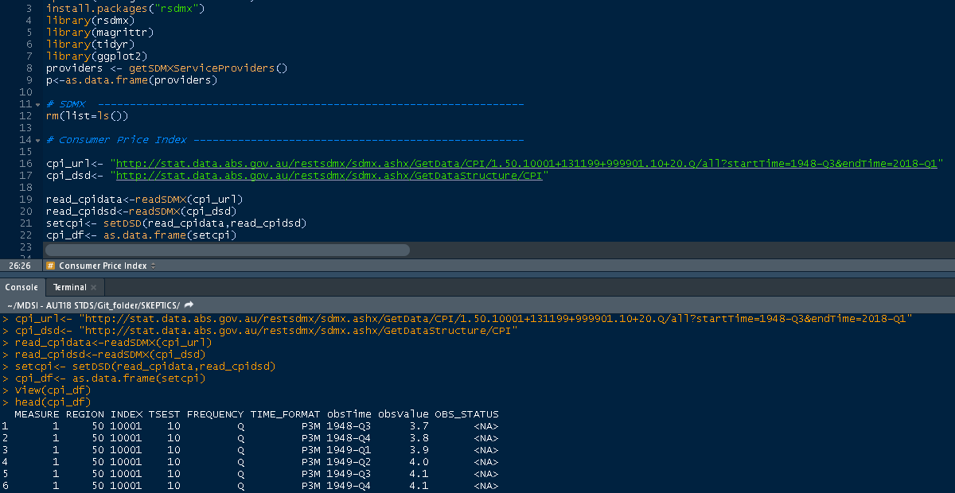

As data does not come in the format required to merge or analyse properly (see data format on screenshot above), we are required to transform obtained datasets to prepare data-frames ready for analysis and data merging.

Transformation of data (consumer price index) into usable data frame for project use

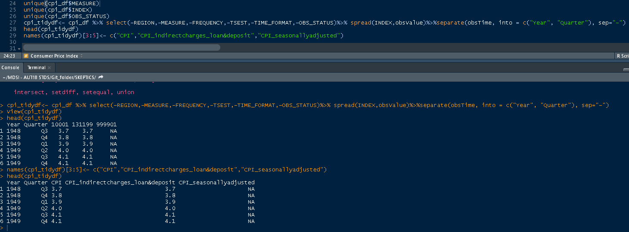

In similar fashion, other datasets have been obtained and transformed using same methods:

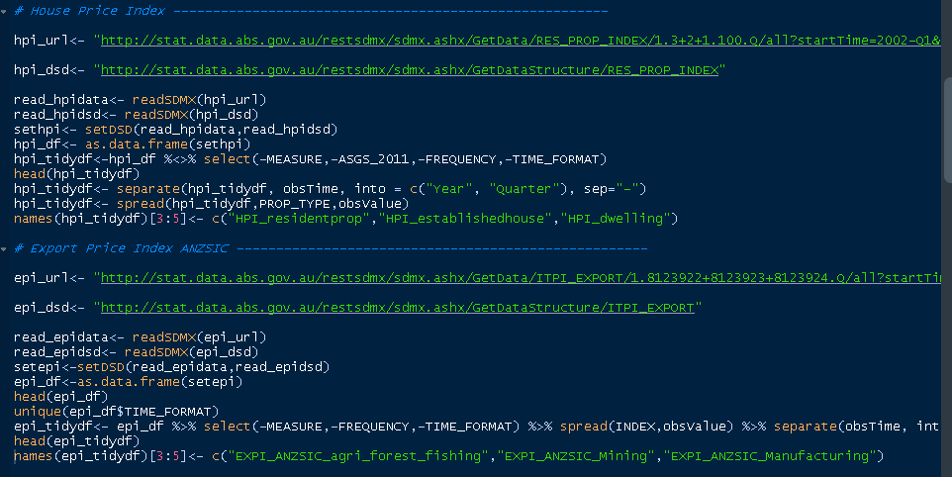

As GDP is derived from multiple economic indicators, and each is composed of multiple indices (derived from multiple datasets), we are employing data-merging techniques using left joins on year and quarter to match corresponding indices over a time-series spread of data.

Merging multiple data-frames on consumer price index into a master data-frame for project

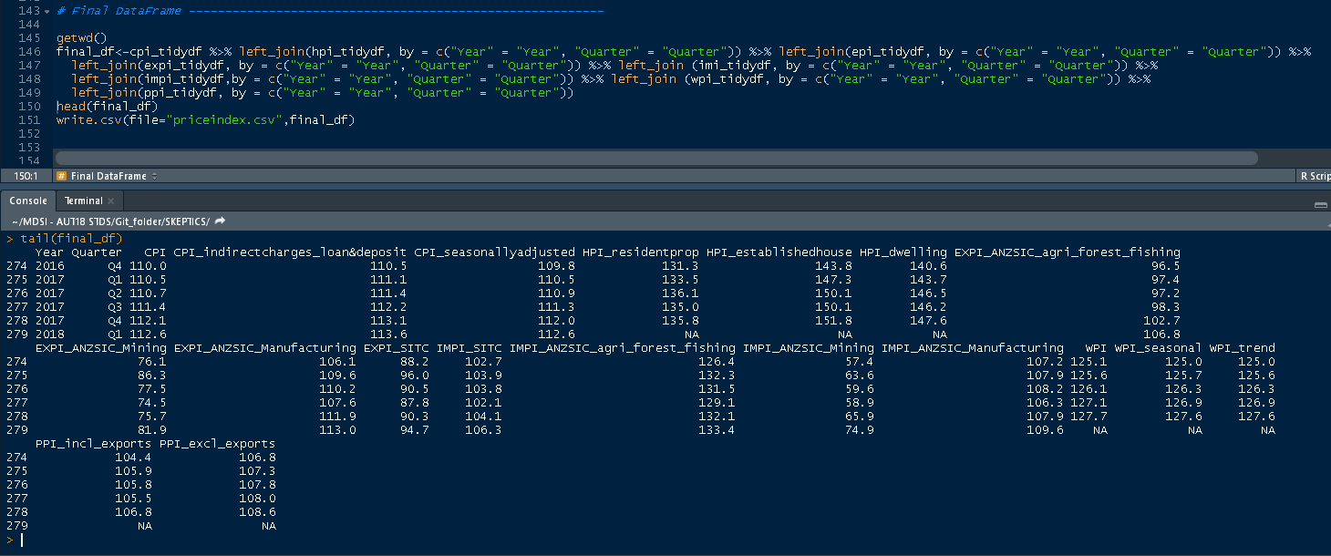

Another sample of data-transformation can be observed on script below where dataset obtained on balance of goods and services was recorded on a monthly frequency and we are required to transform the values into quartile equivalents in order to merge with other datasets

Transforming a monthly frequency index into quarters

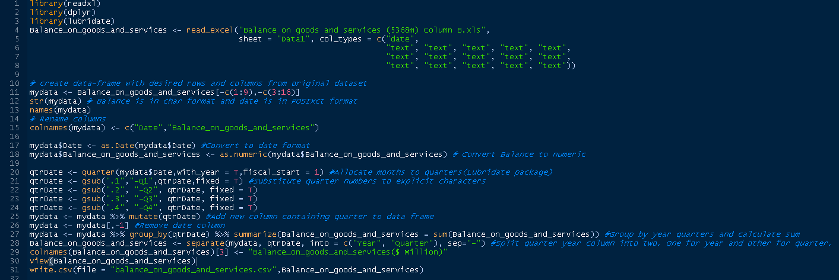

Some of the data required for analysis does not come from data sources offering API interfaces to obtain them therefore we are required to download and import the csv, xls dataset and manipulate as required.

Importing downloaded (.xls) dataset and transformation to quarters

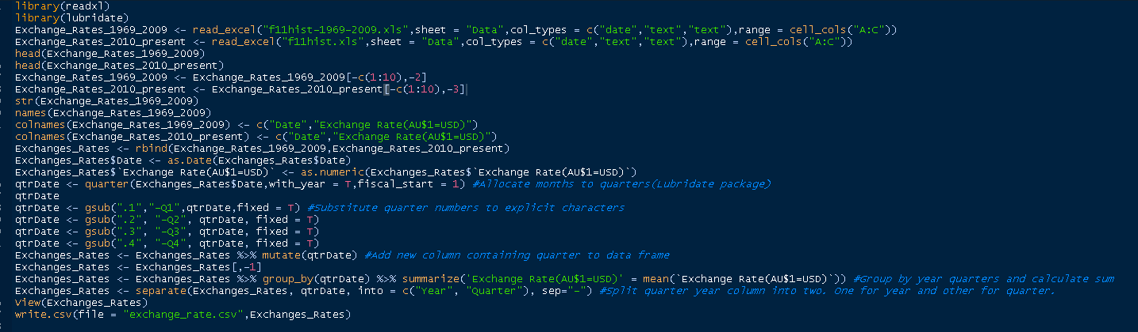

**Code:**

|  |  |
| --- | --- |
|  | # First Steps loading Required Packages ----------------------------------- |
|  | #rm(list=ls()) |
|  | check.packages <- function(pkg){ |
|  | new.pkg <- pkg[!(pkg %in% installed.packages()[, "Package"])] |
|  | if (length(new.pkg)) |
|  | install.packages(new.pkg, dependencies = TRUE) |
|  | sapply(pkg, require, character.only = TRUE) |
|  | } |
|  |  |
|  | packages<-c("ggplot2", "rsdmx", "magrittr", "tidyr", "readxl", "dplyr","lubridate") #required packages |
|  | check.packages(packages) # Calling check.packages function |
|  |  |
|  | options(stringsAsFactors = FALSE) |
|  |  |
|  | # SDMX -------------------------------------------------------------------- |
|  |  |
|  | providers <- getSDMXServiceProviders() |
|  | p<-as.data.frame(providers) |
|  |  |
|  | getwd() |
|  |  |
|  | # Balance of goods and Services in Millions ------------------------------- |
|  |  |
|  | Balance\_on\_goods\_and\_services <- read\_excel("536802.xls", |
|  | sheet = "Data1", col\_types = c("date", |
|  | "text"),range = cell\_cols("A:B")) |
|  |  |
|  | # create data-frame with desired rows and columns from original dataset |
|  | mydata <- Balance\_on\_goods\_and\_services[-c(1:9),] |
|  | str(mydata) # Balance is in char format and date is in POSIXct format |
|  | names(mydata) |
|  | # Rename columns |
|  | colnames(mydata) <- c("Date","Balance\_on\_goods\_and\_services") |
|  |  |
|  | mydata$Date <- as.Date(mydata$Date) #Convert to date format |
|  | mydata$Balance\_on\_goods\_and\_services <- as.numeric(mydata$Balance\_on\_goods\_and\_services) # Convert Balance to numeric |
|  |  |
|  | qtrDate <- quarter(mydata$Date,with\_year = T,fiscal\_start = 1) #Allocate months to quarters(Lubridate package) |
|  | qtrDate <- gsub(".1","-Q1",qtrDate,fixed = T) #Substitute quarter numbers to explicit characters |
|  | qtrDate <- gsub(".2", "-Q2", qtrDate, fixed = T) |
|  | qtrDate <- gsub(".3", "-Q3", qtrDate, fixed = T) |
|  | qtrDate <- gsub(".4", "-Q4", qtrDate, fixed = T) |
|  | mydata <- mydata %>% mutate(qtrDate) #Add new column containing quarter to data frame |
|  | mydata <- mydata[,-1] #Remove date column |
|  | mydata <- mydata %>% group\_by(qtrDate) %>% summarize(Balance\_on\_goods\_and\_services = sum(Balance\_on\_goods\_and\_services)) #Group by year quarters and calculate sum |
|  | Balance\_on\_goods\_and\_services <- separate(mydata, qtrDate, into = c("Year", "Quarter"), sep="-") #Split quarter year column into two. One for year and other for quarter. |
|  | colnames(Balance\_on\_goods\_and\_services)[3] <- "Balance\_on\_goods\_and\_services($ Million)" |
|  | head(Balance\_on\_goods\_and\_services) |
|  | glimpse(Balance\_on\_goods\_and\_services) |
|  | #write.csv(file = "balance\_on\_goods\_and\_services.csv",Balance\_on\_goods\_and\_services) |
|  |  |
|  |  |
|  | # Business Indicators ----------------------------------------------------- |
|  |  |
|  | url <- "http://stat.data.abs.gov.au/restsdmx/sdmx.ashx/GetData/QBIS/10+50+90+110.TOTAL.0.99.10+20+30.Q/all?startTime=1985-Q1&endTime=2017-Q4" |
|  | business\_indicators <- readSDMX(url,dsd = T) |
|  | business\_indicators <- as.data.frame(business\_indicators) |
|  | business\_indicators <- business\_indicators[,c("MEASURE","TSEST","obsTime","obsValue")] |
|  | head(business\_indicators) |
|  |  |
|  | unique(business\_indicators$MEASURE) |
|  | # Measure - 10-Sales($ Million), 50-Inventories($ Million), 90-Wages, 110 - Gross Operating Profits |
|  | unique(business\_indicators$TSEST) |
|  | #TSEST - 10-Original, 20-Seasonally Adjusted, 30-Trend |
|  | business\_indicators$MEASURE[business\_indicators$MEASURE == '10'] <- "Sales($ Million)" |
|  | business\_indicators$MEASURE[business\_indicators$MEASURE == '50'] <- "Inventories($ Million)" |
|  | business\_indicators$MEASURE[business\_indicators$MEASURE == '90'] <- "Wages($ Million)" |
|  | business\_indicators$MEASURE[business\_indicators$MEASURE == '110'] <- "Gross Operating Profit($ Million)" |
|  | unique(business\_indicators$MEASURE) |
|  | #business\_indicators %>% count(MEASURE) #Inventories seem to be inconsistent with others |
|  | #business\_indicators$MEASURE <- as.factor(business\_indicators$MEASURE) |
|  | business\_indicators$TSEST[business\_indicators$TSEST== '10'] <- "Original" #132 |
|  | business\_indicators$TSEST[business\_indicators$TSEST== '20'] <- "Seasonally adjusted" #68 |
|  | business\_indicators$TSEST[business\_indicators$TSEST == '30'] <- "Trend" #68 |
|  | business\_indicators\_tidy\_df<- business\_indicators %>% dplyr::filter(TSEST=="Original") %>% |
|  | spread(MEASURE,obsValue) %>% |
|  | separate( obsTime, into = c("Year", "Quarter"), sep="-") %>% |
|  | select(-TSEST) |
|  | head(business\_indicators\_tidy\_df) |
|  |  |
|  | #Expenditure---------------------------------------------------- |
|  |  |
|  | url <- "http://stat.data.abs.gov.au/restsdmx/sdmx.ashx/GetData/CAPEX/1.999.-.0.10+20+30.Q/all?startTime=1987-Q2&endTime=2017-Q4" |
|  | Expenditure <- as.data.frame(readSDMX(url)) |
|  | head(Expenditure) |
|  | unique(Expenditure$STATE) |
|  | Expenditure$TSEST[Expenditure$TSEST == '10'] <- "Original" #132 |
|  | Expenditure$TSEST[Expenditure$TSEST == '20'] <- "Seasonally adjusted" #68 |
|  | Expenditure$TSEST[Expenditure$TSEST == '30'] <- "Trend" #68 |
|  |  |
|  | # Expenditure.Original <- filter(GOP, TSEST == "Original")$obsValue |
|  | # Expenditure.SeasonallyAdjusted <- filter(GOP, TSEST == "SeasonallyAdjusted") |
|  | # Expenditure.Trend <- filter(GOP, TSEST == "Trend") |
|  | head(Expenditure) |
|  | Expenditure\_tidydf<- Expenditure %>% dplyr::filter(TSEST=="Original") %>% |
|  | separate( obsTime, into = c("Year", "Quarter"), sep="-") %>% |
|  | select(-TSEST,-EXP,-STATE,-IND,-FREQUENCY,-TIME\_FORMAT,-OBS\_STATUS,-ASSET) |
|  | colnames(Expenditure\_tidydf)[3] <- "Expenditure($ Million)" |
|  | head(Expenditure) |
|  |  |
|  | # Exchange Rates ---------------------------------------------------------- |
|  |  |
|  | Exchange\_Rates\_1969\_2009 <- readxl::read\_excel("f11hist-1969-2009.xls",sheet = "Data",col\_types = c("date","text","text"),range = cell\_cols("A:C")) |
|  | Exchange\_Rates\_2010\_present <- read\_excel("f11hist.xls",sheet = "Data",col\_types = c("date","text","text"),range = cell\_cols("A:C")) |
|  | head(Exchange\_Rates\_1969\_2009) |
|  | head(Exchange\_Rates\_2010\_present) |
|  | Exchange\_Rates\_1969\_2009 <- Exchange\_Rates\_1969\_2009[-c(1:10),-2] |
|  | Exchange\_Rates\_2010\_present <- Exchange\_Rates\_2010\_present[-c(1:10),-3] |
|  | str(Exchange\_Rates\_1969\_2009) |
|  | names(Exchange\_Rates\_1969\_2009) |
|  | colnames(Exchange\_Rates\_1969\_2009) <- c("Date","Exchange Rate(AU$1=USD)") |
|  | colnames(Exchange\_Rates\_2010\_present) <- c("Date","Exchange Rate(AU$1=USD)") |
|  | Exchanges\_Rates <- rbind(Exchange\_Rates\_1969\_2009,Exchange\_Rates\_2010\_present) # Adding Rows from both the sheets |
|  | Exchanges\_Rates$Date <- as.Date(Exchanges\_Rates$Date) |
|  | Exchanges\_Rates$`Exchange Rate(AU$1=USD)` <- as.numeric(Exchanges\_Rates$`Exchange Rate(AU$1=USD)`) |
|  | qtrDate <- quarter(Exchanges\_Rates$Date,with\_year = T,fiscal\_start = 1) #Allocate months to quarters(Lubridate package) |
|  | qtrDate |
|  | qtrDate <- gsub(".1","-Q1",qtrDate,fixed = T) #Substitute quarter numbers to explicit characters |
|  | qtrDate <- gsub(".2", "-Q2", qtrDate, fixed = T) |
|  | qtrDate <- gsub(".3", "-Q3", qtrDate, fixed = T) |
|  | qtrDate <- gsub(".4", "-Q4", qtrDate, fixed = T) |
|  | Exchanges\_Rates <- Exchanges\_Rates %>% mutate(qtrDate) #Add new column containing quarter to data frame |
|  | Exchanges\_Rates <- Exchanges\_Rates[,-1] |
|  | Exchanges\_Rates\_tidydf <- Exchanges\_Rates %>% |
|  | group\_by(qtrDate) %>% |
|  | summarize('Exchange Rate(AU$1=USD)' = mean(`Exchange Rate(AU$1=USD)`)) #Group by year quarters and calculate mean |
|  |  |
|  | Exchanges\_Rates\_tidydf <- separate(Exchanges\_Rates\_tidydf, qtrDate, into = c("Year", "Quarter"), sep="-") #Split quarter year column into two. One for year and other for quarter. |
|  | head(Exchanges\_Rates\_tidydf) |
|  | #write.csv(file = "exchange\_rate.csv",Exchanges\_Rates) |
|  |  |
|  |  |
|  | # GDP --------------------------------------------------------------------- |
|  |  |
|  | url <- "http://stats.oecd.org/restsdmx/sdmx.ashx/GetData/QNA/AUS.B1\_GE.CPCARSA.Q/all?startTime=1960-Q1&endTime=2018-Q1" |
|  | GDP <- as.data.frame(readSDMX(url,dsd = T)) |
|  | str(GDP) |
|  |  |
|  | GDP <- GDP[,c("obsTime","obsValue")] |
|  | head(GDP,60) |
|  | GDP <- separate(GDP,obsTime, into = c("Year", "Quarter"), sep="-") |
|  | colnames(GDP)[3] <- "GDP(US$ Millions)" |
|  | View(GDP) |
|  |  |
|  | #write.csv(file = "GDP.csv",GDP) |
|  |  |
|  |  |
|  | # Human Development Index ------------------------------------------------- |
|  |  |
|  | HumanDevelopmentIndex <- read.csv("Human Development Index (HDI).csv",header = F) |
|  | head(HumanDevelopmentIndex) |
|  | HumanDevelopmentIndex <- filter(HumanDevelopmentIndex,V2 == "Country" | V2==" Australia") |
|  | HumanDevelopmentIndex |
|  | Years <- 1990:2015 |
|  | HDI <- as.numeric(HumanDevelopmentIndex[2,-c(1,2)]) |
|  | HDI <- data.frame(Year = Years,HDI = HDI ) |
|  | names(HDI)[2] <- "HDI(%)" |
|  | HDI <- HDI[rep(seq\_len(nrow(HDI)), each=4),] |
|  | rownames(HDI) <- c() |
|  | Quarter <- rep(c("Q1","Q2","Q3","Q4"),length(Years)) #Create quarters |
|  | HDI <- cbind(Quarter,HDI) |
|  | HDI <- HDI[,c(2,1,3)] #Reorder columns |
|  | summary(HDI) |
|  | HDI$Year<-as.character(HDI$Year) |
|  | head(HDI) |
|  | #write.csv(file="human\_development\_index.csv",HDI) |
|  |  |
|  |  |
|  | # Interest Rates ---------------------------------------------------------- |
|  |  |
|  | interestRates <- read\_excel("f01hist.xls",sheet = "Data",col\_types = c("date","text","text","text","text","text"),range = cell\_cols("A:F")) |
|  | interestRates <- interestRates[-c(1:10),c(1,5)] |
|  | head(interestRates,n=15) |
|  | #3-month BABs/NCDs Bank Accepted Bills/Negotiable Certificates of Deposit-3 months; monthly average |
|  | colnames(interestRates) <- c("Date","Interest rates") |
|  | interestRates$Date <- as.Date(interestRates$Date) |
|  | interestRates$`Interest rates` <- as.numeric(interestRates$`Interest rates`) |
|  | qtrDate <- quarter(interestRates$Date,with\_year = T,fiscal\_start = 1) #Allocate months to quarters(Lubridate package) |
|  | qtrDate |
|  | qtrDate <- gsub(".1","-Q1",qtrDate,fixed = T) #Substitute quarter numbers to explicit characters |
|  | qtrDate <- gsub(".2", "-Q2", qtrDate, fixed = T) |
|  | qtrDate <- gsub(".3", "-Q3", qtrDate, fixed = T) |
|  | qtrDate <- gsub(".4", "-Q4", qtrDate, fixed = T) |
|  | interestRates <- interestRates %>% mutate(qtrDate) #Add new column containing quarter to data frame |
|  | interestRates <- interestRates[,-1] |
|  | interestRates <- interestRates %>% |
|  | group\_by(qtrDate) %>% |
|  | summarize(Interest\_Rates= mean(`Interest rates`)) |
|  |  |
|  | interestRates <- separate(interestRates, qtrDate, into = c("Year", "Quarter"), sep="-") #Split quarter year column into two. One for year and other for quarter. |
|  | head(interestRates) |
|  | colnames(interestRates)[3] <- "3-month Monthly Average Interest Rates(%)" |
|  | #write.csv(file="interest\_rates.csv",interestRates) |
|  |  |
|  |  |
|  | # Unemployment Rate ------------------------------------------------------- |
|  |  |
|  | unemployment <- read.csv("DP\_LIVE\_28042018200453939.csv",header = T) |
|  | names(unemployment)[1]<- "LOCATION" |
|  | unemployment.AUS <- filter(unemployment,LOCATION =="AUS") |
|  | unemployment.AUS <- unemployment.AUS[,c("TIME","Value")] |
|  | unemployment.AUS <- separate(unemployment.AUS, TIME, into = c("Year", "Quarter"), sep="-") |
|  | colnames(unemployment.AUS)[3] <- c("Percentage unemployed %") |
|  | head(unemployment.AUS) |
|  | #write.csv(file="unemployment.csv",unemployment.AUS) |
|  |  |
|  | # Consumer Price Index ---------------------------------------------------- |
|  |  |
|  | cpi\_url<- "http://stat.data.abs.gov.au/restsdmx/sdmx.ashx/GetData/CPI/1+2+3.50.10001+999901.10+20.Q/all?startTime=1948-Q3&endTime=2018-Q1" |
|  | cpi\_dsd<- "http://stat.data.abs.gov.au/restsdmx/sdmx.ashx/GetDataStructure/CPI" |
|  |  |
|  | read\_cpidata <-readSDMX(cpi\_url) |
|  | read\_cpidsd <-readSDMX(cpi\_dsd) |
|  | setcpi <- setDSD(read\_cpidata,read\_cpidsd) |
|  | cpi\_df <- as.data.frame(setcpi) |
|  | head(cpi\_df) |
|  | unique(cpi\_df$MEASURE) # 1- Index 2-Percentage change within quarters 3- Percentage change from corresponding quarter of Previous year |
|  | unique(cpi\_df$TSEST) # 10- Original 20- Seasonal |
|  | unique(cpi\_df$INDEX) # 10001 All groups CPI 999901 All groups Season data |
|  |  |
|  | # Fetching original CPI data only --------------------------------------------- |
|  |  |
|  | cpi\_df<- cpi\_df %>% filter(TSEST=="10",INDEX=="10001", MEASURE %in% c("1")) |
|  |  |
|  | cpi\_tidydf <- cpi\_df %>% |
|  | select(-REGION,-FREQUENCY,-TSEST,-TIME\_FORMAT,-OBS\_STATUS,-INDEX)%>% |
|  | spread(MEASURE,obsValue)%>% |
|  | separate(obsTime, into = c("Year", "Quarter"), sep="-") |
|  | head(cpi\_tidydf) |
|  | names(cpi\_tidydf)[3] <- c("Consumer Price Index(CPI)") |
|  | head(cpi\_tidydf) |
|  |  |
|  |  |
|  | # Labourforce ------------------------------------------------------------- |
|  |  |
|  | Labourforce <- read\_excel("6202001.xls", |
|  | sheet = "Data1",skip=9,col\_types="date",range=cell\_cols("A")) |
|  | Labourforce1 <- read\_excel("6202001.xls", |
|  | sheet = "Data1",col\_types="text",range=cell\_cols("CP")) |
|  | # create data-frame with desired rows and columns from original dataset |
|  | Labourforce <- na.omit(Labourforce) |
|  | Labourforce1 <- Labourforce1[-c(1:9),] |
|  | Labourdata <- cbind(Labourforce,Labourforce1) |
|  | View(Labourdata) |
|  | names(Labourdata) <- c("Date","Labourforce") # Rename columns |
|  | str(Labourdata) |
|  | Labourdata$Date <- as.Date(Labourdata$Date) #Convert to date format |
|  | Labourdata$Labourforce <- as.numeric(Labourdata$Labourforce) # Convert Balance to numeric |
|  |  |
|  | qtrDate <- quarter(Labourdata$Date,with\_year = T,fiscal\_start = 1) #Allocate months to quarters(Lubridate package) |
|  | qtrDate <- gsub(".1","-Q1",qtrDate,fixed = T) #Substitute quarter numbers to explicit characters |
|  | qtrDate <- gsub(".2", "-Q2", qtrDate, fixed = T) |
|  | qtrDate <- gsub(".3", "-Q3", qtrDate, fixed = T) |
|  | qtrDate <- gsub(".4", "-Q4", qtrDate, fixed = T) |
|  | Labourdata <- Labourdata %>% mutate(qtrDate) #Add new column containing quarter to data frame |
|  | Labourdata <- Labourdata[,-1] #Remove date column |
|  | Labourdata <- Labourdata %>% |
|  | group\_by(qtrDate) %>% |
|  | summarize(Labourforce = mean(Labourforce)) #Group by year quarters and calculate sum |
|  | Labourdata <- separate(Labourdata, qtrDate, into = c("Year", "Quarter"), sep="-") #Split quarter year column into two. One for year and other for quarter. |
|  | head(Labourdata) |
|  |  |
|  | # Preparing Master Datasheet ---------------------------------------------- |
|  |  |
|  | join\_df <- cpi\_tidydf %>% |
|  | left\_join(business\_indicators\_tidy\_df,by=c("Year" = "Year", "Quarter" = "Quarter")) %>% |
|  | left\_join(Expenditure\_tidydf,by=c("Year" = "Year", "Quarter" = "Quarter")) %>% |
|  | left\_join(unemployment.AUS,by=c("Year" = "Year", "Quarter" = "Quarter")) %>% |
|  | left\_join(interestRates,by=c("Year" = "Year", "Quarter" = "Quarter")) %>% |
|  | left\_join(HDI,by=c("Year" = "Year", "Quarter" = "Quarter")) %>% |
|  | left\_join(GDP,by=c("Year" = "Year", "Quarter" = "Quarter")) %>% |
|  | left\_join(Balance\_on\_goods\_and\_services,by=c("Year" = "Year", "Quarter" = "Quarter")) %>% |
|  | left\_join(Exchanges\_Rates\_tidydf,by=c("Year" = "Year", "Quarter" = "Quarter")) %>% |
|  | left\_join(Labourdata,by=c("Year" = "Year", "Quarter" = "Quarter")) |
|  |  |
|  | head(join\_df) |
|  |  |
|  | # Filtering data from 1970 ------------------------------------------------ |
|  |  |
|  | master\_df <- join\_df %>% filter(Year >= "1970") |
|  | write.csv(file="master.csv",master\_df) |